**Test Case 0008 (part 1)**

**System:** VirtuCardsClient & VirtuCardsHost

**Description:** Tests that verifies the chat can be muted & disabled

**Severity:** 3

**Instructions**

1. Start VirtuCardClient application
2. Click the button labeled “Sign In”
3. Enter “virtucards01@gmail.com” into the text input labeled “Enter email…”
4. Enter “Testing1” into the text input labeled “Enter password…”
5. Press the button labeled “Login”
6. A window should appear saying “Login Success”
7. Press the OK button that appears on that window
8. Start VirtuCardHost application
9. Repeat steps 2-7 but on the VirtuCardHost application
10. The checkbox “Allow Host to Join” should be checked on the host
11. Press the Create Game button
12. In the VirtuCardClient application enter the 6-character room code found on the host’s screen into the field labeled “Enter Code…”
13. Press the Join Game button on the client
14. After the name TestCase0001 appears in the player list on the host side, press the Start Game button
15. Press “Normal chat” on the host side for the drop-down menu to show up

**Expected result:** The chat should be visible when you join a game since nothing has been changed and the default chat is visible. When the player presses the “Normal chat”, the drop-down menu with 3 chat options should show up.

**Test Case 0008 (part 2)**

**System:** VirtuCardsClient & VirtuCardsHost

**Description:** Tests that verifies the chat can be muted & disabled

**Severity:** 3

**Instructions**

1. Start VirtuCardClient application
2. Click the button labeled “Sign In”
3. Enter “virtucards01@gmail.com” into the text input labeled “Enter email…”
4. Enter “Testing1” into the text input labeled “Enter password…”
5. Press the button labeled “Login”
6. A window should appear saying “Login Success”
7. Press the OK button that appears on that window
8. Start VirtuCardHost application
9. Repeat steps 2-7 but on the VirtuCardHost application
10. The checkbox “Allow Host to Join” should be checked on the host
11. Press the Create Game button
12. In the VirtuCardClient application enter the 6-character room code found on the host’s screen into the field labeled “Enter Code…”
13. Press the Join Game button on the client
14. After the name TestCase0001 appears in the player list on the host side, press the Start Game button
15. Press “Normal chat” on the host side for the drop-down menu to show up
16. Press “Disable chat” in the drop-down menu on the host side

**Expected result:** The chat should be visible when you join a game since nothing has been changed and the default chat is visible. However, when the host presses disable chat in the drop-down menu, the chat should disappear in the host, and the client-side with the sign that says “Host has disabled the chat” will appear.

**Test Case 0008 (part 3)**

**System:** VirtuCardsClient & VirtuCardsHost

**Description:** Tests that verifies the chat can be muted & disabled

**Severity:** 3

**Instructions**

1. Start VirtuCardClient application
2. Click the button labeled “Sign In”
3. Enter “virtucards01@gmail.com” into the text input labeled “Enter email…”
4. Enter “Testing1” into the text input labeled “Enter password…”
5. Press the button labeled “Login”
6. A window should appear saying “Login Success”
7. Press the OK button that appears on that window
8. Start VirtuCardHost application
9. Repeat steps 2-7 but on the VirtuCardHost application
10. The checkbox “Allow Host to Join” should be checked on the host
11. Press the Create Game button
12. In the VirtuCardClient application enter the 6-character room code found on the host’s screen into the field labeled “Enter Code…”
13. Press the Join Game button on the client
14. After the name TestCase0001 appears in the player list on the host side, press the Start Game button
15. Press “Normal chat” on the host side for the drop-down menu to show up
16. Press “Mute chat” in the drop-down menu on the host side

**Expected result:** The chat should be visible when you join a game since nothing has been changed and the default chat is visible. If the host presses mute chat, the players will not be able to see the chat from the Host side, but the chat will still be open on the client-side for players to chat.

**Test Case 0008 (part 4)**

**System:** VirtuCardsClient & VirtuCardsHost

**Description:** Tests that verifies the chat can be muted & disabled

**Severity:** 3

**Instructions**

1. Start VirtuCardClient application
2. Click the button labeled “Sign In”
3. Enter “virtucards01@gmail.com” into the text input labeled “Enter email…”
4. Enter “Testing1” into the text input labeled “Enter password…”
5. Press the button labeled “Login”
6. A window should appear saying “Login Success”
7. Press the OK button that appears on that window
8. Start VirtuCardHost application
9. Repeat steps 2-7 but on the VirtuCardHost application
10. The checkbox “Allow Host to Join” should be checked on the host
11. Press the Create Game button
12. In the VirtuCardClient application enter the 6-character room code found on the host’s screen into the field labeled “Enter Code…”
13. Press the Join Game button on the client
14. After the name TestCase0001 appears in the player list on the host side, press the Start Game button
15. Press “Normal chat” on the host side for the drop-down menu to show up
16. Press “Disable chat” in the drop-down menu on the host side
17. Press “Normal chat” in the drop-down menu on the host side

**Expected result:** The chat should be visible when you join a game since nothing has been changed and the default chat is visible. However, when the host presses disable chat in the drop-down menu, the chat should disappear in the host and the client-side with the sign that says “Host has disabled the chat”. When the host presses normal chat, the players will be able to see the chat on the host and the client-side with the sign that says “Host has disabled the chat” gone.

**Pictures**

Part 1

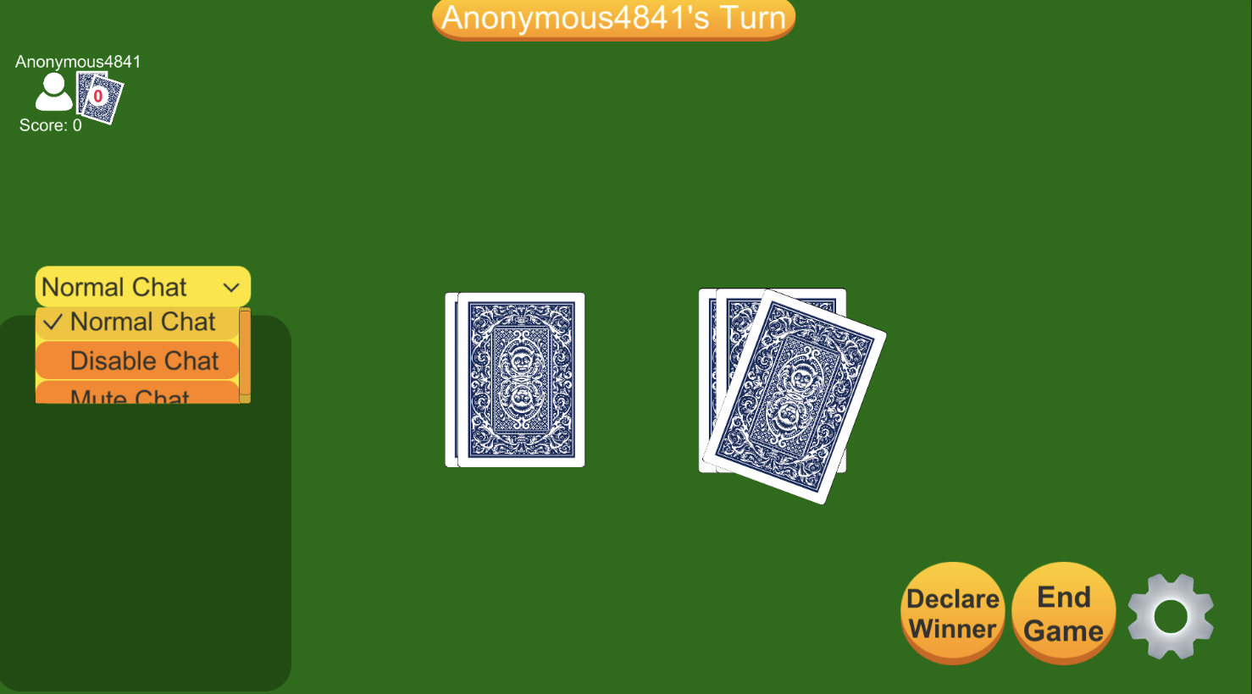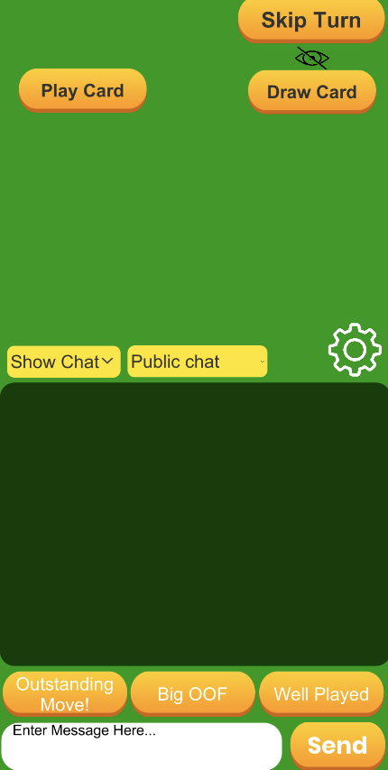

Clicked on “Normal Chat” and the dropdown menu is shown with three options. Since the default dropdown is normal, the chat is shown in both Host and Client.

Part 2

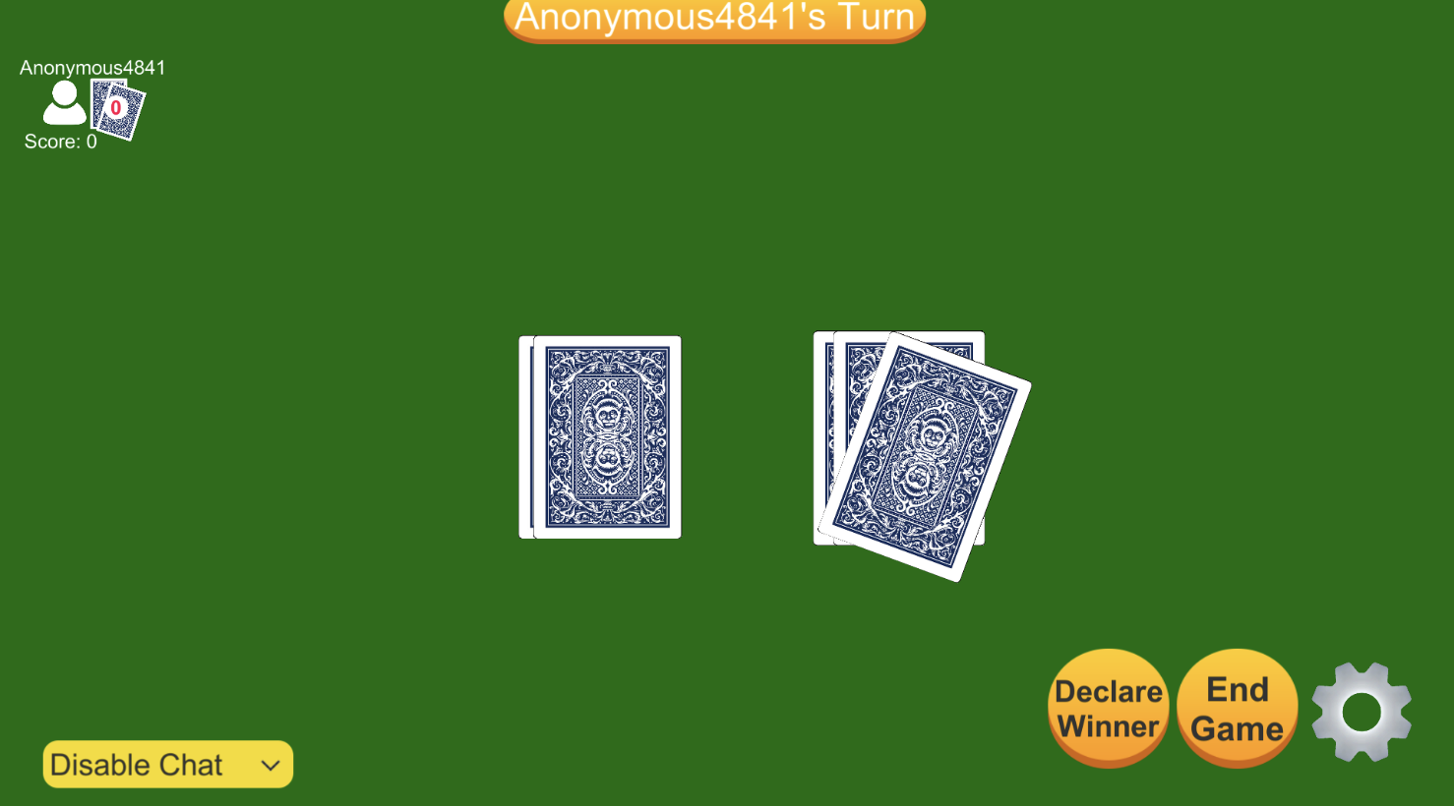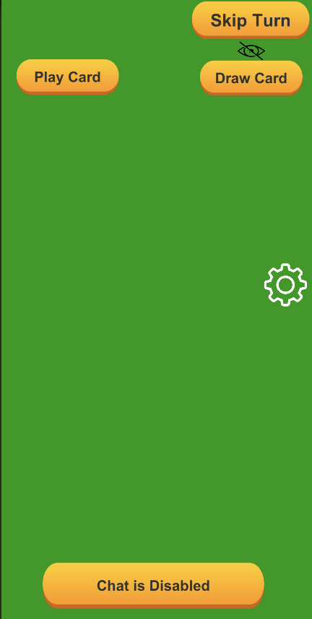

When the host chooses to disable chat, the chat panel on the host and client will disappear and the sign that says “Chat is disabled” will show up.

Part 3

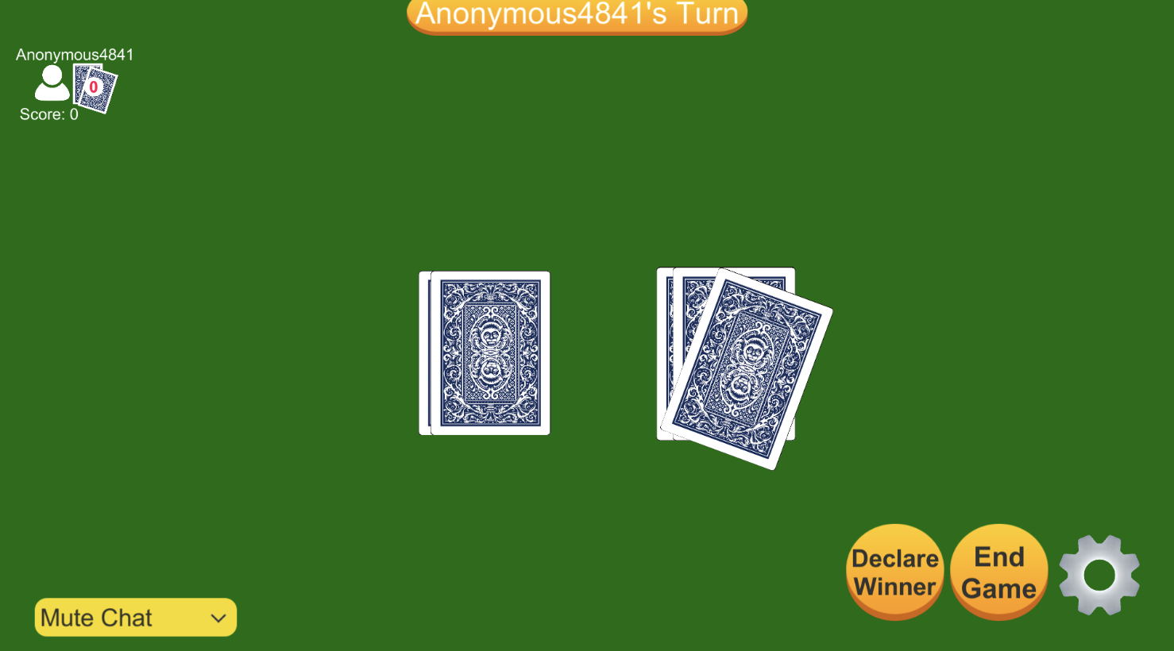

The chat is muted, which means that the chat panel on the host side will not show up, but the chat will still be available on the client-side.

Part 4

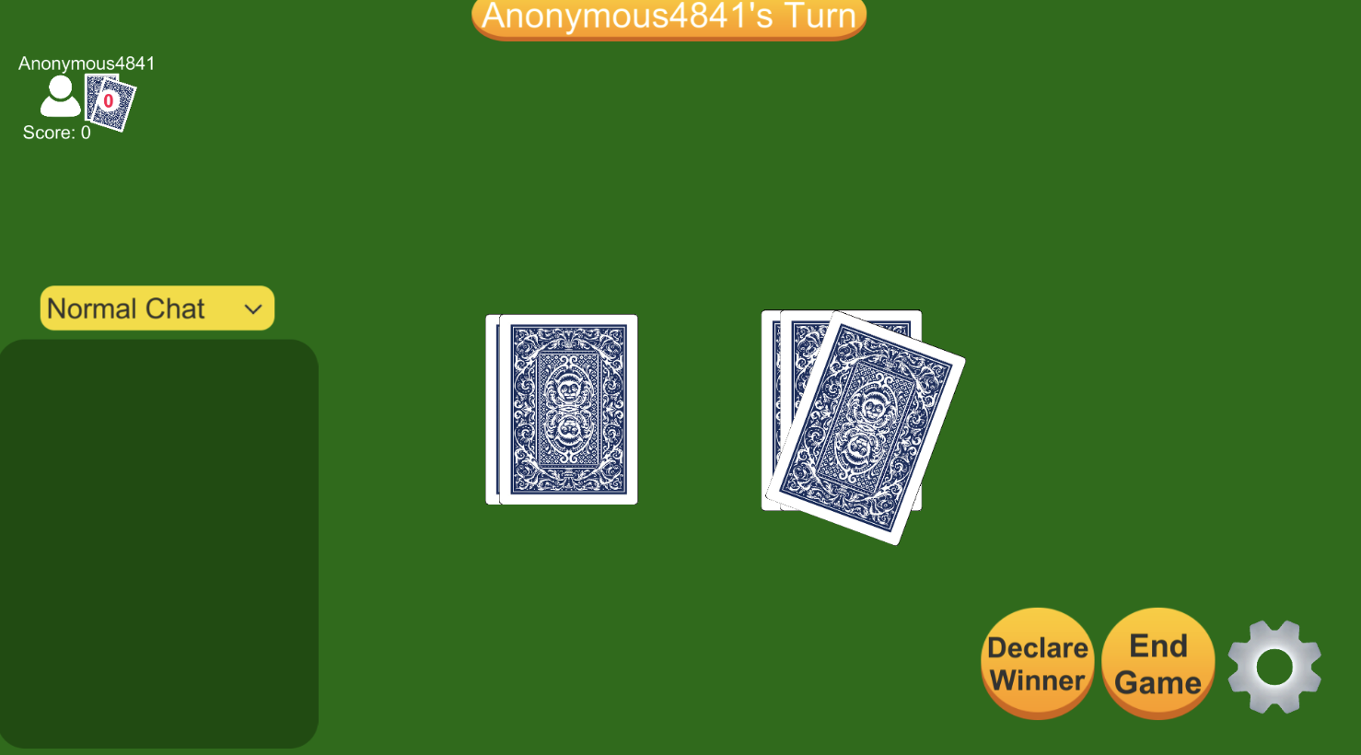

After clicking all of the chat options, when you press “Normal Chat” in the end, it will show the chat panel on both host and client-side and the chat will be back to normal.